Exchequer Enterprise

Visual Report Writer

Contents

Introduction 1
Directories 1
Projects 2
X:\ENTRPRSE\GUIRW\Basic UI Test\ENTRW.dpr 2
X:\ENTRPRSE\GUIRW\Basic UI Test\RWUITest.dpr – NO LONGER USED 2
X:\ENTRPRSE\GUIRW\PlugIn \enRWMenu.dpr – NO LONGER USED 2
X:\ENTRPRSE\GUIRW\RepEngine\RepEngine.dpr 2
X:\ENTRPRSE\GUIRW\ReportEngine.Old\RepEngine.dpr – NO LONGER USED 2
X:\ENTRPRSE\GUIRW\RWReader\RWReader.dpr 2
X:\ENTRPRSE\GUIRW\RWReader\TestTree.dpr 2
Data Files 3
Reports\ERWDisp.Dat 3
Reports\RWTree.Dat 3
Reports\VRWTree.Dat 3
Reports\RWUser.Dat – NO LONGER USED 3
Reports\*.ERF 3
Reports\VRWSec.Dat 3
Swap\~RWxxx.TMP 3
Swap\$Repxxx.SWP 3
Code in X:\ENTRPRSE\GUIRW\ 4
DataDict.Pas 4
Code in X:\ENTRPRSE\GUIRW\Basic UI Test 5
AboutU.Pas 5
CnvrtTree.pas 5
DemoWarn.pas – NO LONGER USED 5
FindRepF.Pas 5
frmRptTreePropertiesU.pas 5
FrmThrdU.pas 5
mainform.pas 5
NewSortEdt.pas 5
printmgr.pas 6
RptCopy.pas 6
RptDesc.pas 7
RptDisp.pas 7
RptProp.pas 7
RptSections.pas 7
RptTree.pas 7
RptTreeEdt.pas 9
RptWizard.pas 9
RWDivider.pas 9
RWFormulaName.pas 9
SortPageEdt.pas 9
TreeSecurity.pas 9
Code in X:\ENTRPRSE\GUIRW\Common 10
CIS.PAS 10
CtrlPrms.pas 10
DLLINT.PAS 10
EntLicence.pas - REMOVED 10
FORMUTIL.PAS 10
GlobalTypes.pas 10
Globtype.pas 10
History.Pas 10
MCUTIL.PAS 10
MCVARS.PAS 10
PAGEDLG.PAS 10
PRINTFRM.PAS 10
RangeFilterDetF.pas 10
RangeFiltersF.pas 10
RECURSE.PAS 11
RECURSER.PAS 11
RepEngIf.Pas 11
RepTreeIF.pas 11
RPCOMMON.PAS 11
RptEngDll.pas 11
RWOPENF.PAS 11
SBSFUNCS.PAS 11
SBSLIST.PAS 11
SERIALNO.PAS 11
VRWReportDataIF.pas 11
Code in X:\ENTRPRSE\GUIRW\Components\Common\ 12
DDFuncs.pas 12
PRNTDLG2.PAS 12
Code in X:\ENTRPRSE\GUIRW\Components\ReportContainer 13
AlignList.pas 13
CtrlList.pas 13
ReportRegion.pas 13
RWRegion.pas 13
Code in X:\ENTRPRSE\GUIRW\Components\ReportControls\ 14
CtrlBase.pas 14
DBFieldSelect.Pas 14
GraphicCtrl.pas 14
RWDBField.pas 14
RWFormula.pas 14
RWFormulaDef.pas 14
RWImage.pas 14
RWLine.pas 14
RWLineSelect.pas 14
RWText.pas 14
RWTextEntry.pas 14
TextCtrl.pas 14
Code in X:\ENTRPRSE\GUIRW\RepEngine 15
DbAccessFilter.pas 15
DBFutil.PAS 15
FrmThrdU.pas 15
oRepEngine.Pas (Formerly RepEngImp.Pas) 15
oRepEngineManager.Pas 15
oRepGenerator (Formerly ReportGen.pas) 15
oRepTree.Pas (Formerly RepTreeIMP.pas) 15
oRepTreeSecurity.pas 15
PRINTFRM.PAS 15
PrntDlg2.pas 15
PrntPrev.pas 15
RepEngine.Dpr 15
RptPersist.pas 15
RptTreeF.pas 16
RWOpenF.Pas 16
RWPRINTR.PAS 16
VarConst.Pas 16
VARFPOSU.PAS 16
VRWReportDataU.pas 16
Code in X:\ENTRPRSE\GUIRW\RWReader 17
oReportDetail.pas 17
oReportTree.pas 17
RWReader.dpr 17
RWRIntF.pas 17
Classes 18
TAccessFilter – GUIRW\ReportEngine\DbAccessFilter.Pas 18
TAlignmentObj - GUIRW\Components\ReportContainer\AlignList.Pas 18
TControlList – GUIRW\Components\ReportContainer\CtrlList.Pas 18
TReportEngine – GUIRW\ReportEngine\RepEngImp.Pas 18
TReportGenerator – GUIRW\ReportEngine\ReportGen.Pas 19
TreportPersistor – GUIRW\ReportEngine\RptPersist.Pas 19
TReportTree – GUIRW\ReportEngine\RepTreeImp.Pas 20
TVRWReportData 20
TReportWriterEngine – RepWrt\Engine\GUIEng.Pas 20
Components 21
TReportCtrlBase – GUIRW\Components\ReportControls\CtrlBase.Pas 21
TGraphicalCtrl – GUIRW\Components\ReportControls\GraphicCtrl.Pas 21
TReportImage – GUIRW\Components\ReportControls\RWImage.Pas 21
TReportLine – GUIRW\Components\ReportControls\RWLine.Pas 21
TRWTextCtrl – GUIRW\Components\ReportControls\TextCtrl.Pas 21
TReportDBField – GUIRW\Components\ReportControls\RWDBField.Pas 21
TReportFormula – GUIRW\Components\ReportControls\RWFormula.Pas 21
TReportText – GUIRW\Components\ReportControls\RWText.Pas 21
TRWDivider – GUIRW\Basic UI Test\RWDivider.Pas 22
TRWRegion – GUIRW\Components\ReportContainer\RWRegion.Pas 22
Third-Party Components 23
VirtualTree 23
Interfaces – RepEngine.Dll 24
IReport_Interface – GUIRW\ReportEngine\ RepEngIF.Pas 24
IRWReport_Interface – GUIRW\ReportEngine\ RepEngIF.Pas 24
IReportTree_Interface – GUIRW\ReportEngine\ RepTreeIF.Pas 24
IRWReportTree_Interface – GUIRW\ReportEngine\ RepTreeIF.Pas 24
IVRWReportData – GUIRW\ReportEngine\VRWReportDataIF.pas 24
Interfaces – RWReader.Dll 24
IReportTree – GUIRW\RWReader\RWRIntf.Pas 24
IReportDetails – GUIRW\RWReader\RWRIntf.Pas 24
Code Walkthrough - Loading A Report 25
Code Walkthrough - Printing a Report 26
User Based Security 27
Proposed Redesign “Kermit” 27

Introduction
This document relates to the rewritten version of the Visual Report Writer, and details the interfaces and classes used.

Directories

X:\ENTRPRSE
│
└───VRW
│
├───EntRW Report Writer Front End Directory
│
├───Common Shared modules for ENTRW & REPENGINE
│
├───RepEngine Report Engine Directory
│
└───RWReader Reader DLL for Windows Report Writer Reports & Tree

Projects
All projects are written using Delphi 6.01.

There is a project group, VRW.bpg, in x:\Entrprse\VRW. This contains the main projects and the test project.

X:\ENTRPRSE\VRW\EntRW\ENTRW.dpr
This is the Visual Report Writer front end.

X:\ENTRPRSE\VRW\RepEngineTests\RepEngineTests.dpr
Unit tests for the revised Report Engine.

X:\ENTRPRSE\VRW\RepEngine\RepEngine.dpr
This is the engine which loads and prints the reports, this is used by the EntRW.Exe front end as well as Sentimail and the Enterprise tools Menu plug-in.

X:\ENTRPRSE\GUIRW\ReportEngine.Old\RepEngine.dpr – NO LONGER USED
This is the engine which loads and prints the reports, this is used by the EntRW.Exe front end as well as Sentimail and the Enterprise tools Menu plug-in.

NOTE: This was replaced in early April 05 by RepEngine\RepEngine.Dpr due to a major restructuring of the DLL to fix various problems opening and closing files.

X:\ENTRPRSE\VRW\RWReader\RWReader.dpr
DLL for accessing the Report Tree and Report Detail from the old Windows Report Writer allowing them to be imported into the Visual Report Writer.

X:\ENTRPRSE\VRW\RWReader\TestTree.dpr
Test application for RWReader.DLL.

Data Files

Reports\ERWDisp.Dat
A binary file containing the Report Display Properties.

Reports\RWTree.Dat – NO LONGER USED

Obsolete (see VRWTree.Dat below)
Contains the Report Tree structure, defined and declared in ReportEngine\RptTreeF.Pas.

NOTE: Due to the design of the file you are limited to 99 folders and then it will start duplicating the 2 char numeric folder Id’s across folders which will cause chaos with loading the report tree.

Reports\VRWTree.Dat
Contains the Visual Report Tree structure, defined and declared in ReportEngine\VRWReportDataIF.pas. This replaces the RWTree.Dat file, and has no limitations on the number of folders. The Report Engine Manager will automatically create this file if it does not exist, and import the reports from RWTree.Dat (if found).

Reports\RWUser.Dat – NO LONGER USED
Contains the User based security settings for the Report Tree, defined and declared in RptTreeF.Pas.

NOTE: Due to bugs the security functionality was pulled from the v5.61 release of the report writer and this file was replaced by VRWSEC.Dat when the security subsystem was rewritten in April 05.

Reports\*.ERF
Individual Report Files, see ERF File Format for more details.

Reports\VRWSec.Dat
Added in April 05 this contains the User/Report Security details.

Swap\~RWxxx.TMP
These files are created when the Report Writer loads a report for editing or printing, they are removed everytime the report writer loads.

Swap\$Repxxx.SWP
These files are created when the Report Writer prints a report, they are left intact after the printing but appear to be tidied away the next time a report is printed.

Code in X:\ENTRPRSE\VRW\

DataDict.Pas
Misc Data File and Data Dictionary routines, functions don’t appear to be used but module is referenced.

Code in X:\ENTRPRSE\EntRW\Basic UI Test

AboutU.Pas
A copy of Enter1.Exe’s Help|About dialog which has been modified to display the EntRW and RepEngine version numbers.

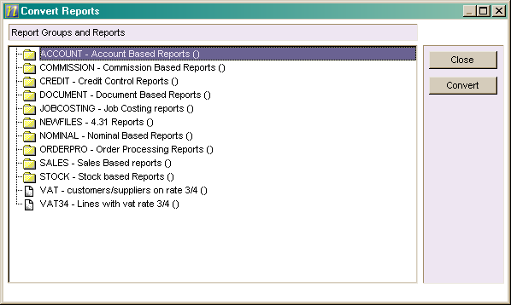
CnvrtTree.pas
Contains TfrmConvertReport that displays the Report Tree from the Windows Report Writer to allow old reports to be imported into the Visual Report Writer.

It uses RWReader.Dll (380k – Statically Linked) to access the old WRW reports and the selected report is passed back to the Report Tree (RptTree.Pas) for conversion and display via a public variable, ImportRptDetails : IReportDetails, on the form.

DemoWarn.pas – NO LONGER USED
Startup Beta Notice displayed by the FormCreate of RptTree.Pas.
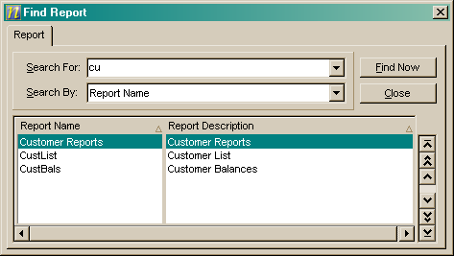

FindRepF.Pas
This is a copy of the Multi-Company Manager Find dialog modified to run off the data loaded into the Report Tree. In this way the search takes into account the Group/Report Security which would have to be explicitely checked if it ran off the data files.

frmRptTreePropertiesU.pas
A form which displays the properties for a report. This is used by the Report Tree display.

FrmThrdU.pas
Threading routines? Although compiled into EntRW.Exe it doesn’t appear to be referenced other than in EntRW.DPR, this module is also duplicated in GUIRW\ReportEngine\.

mainform.pas
This is the Report Designer window where the report layout is designed:-

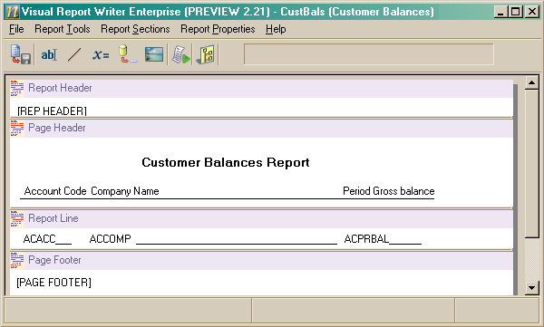
BuildImportedReport – This method takes the IReportDetails object returned by CnvrtTree.Pas and converts it into a VRW Report.

BuildReport – Called from RunReportWizard this method sets up all the controls for the details specified in the wizard.

FormShow – This event handler loads existing reports by calling ShowReport and imports reports from the Windows RW using the BuildImportedReport method.

NewReport – Called from the Add button on the Report Tree it tidies up the designer window and calls RunReportWizard.

RunReportWizard – Called from NewReport to display the Add Report Wizard (RptWizard.Pas) and if the wizard is completed it calls CollateWizardParams to copy the details into a local variable which is then passed into BuildReport to load the resulting info into the designer.

ShowReport – This method is used to load an existing report into the designer and is called from the FormShow event.

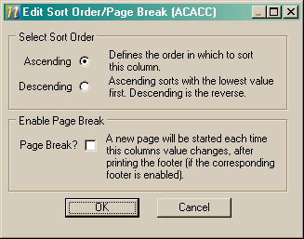
NewSortEdt.pas
This is the Edit Sort Order dialog from the sorting page of the Add Report Wizard.

printmgr.pas
Contains the TPrintMgr class, although compiled into EntRW.Exe it doesn’t appear to be referenced other than in EntRW.DPR.

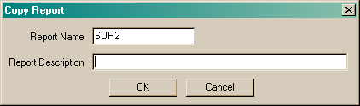
RptCopy.pas
This is the dialog displayed by the Copy button on the Report Tree to ask for the new name and description of the report.

RptDesc.pas
A report name/description dialog, although referenced from EntRW.DPR and MainForm.Pas it doesn’t appear to be used.

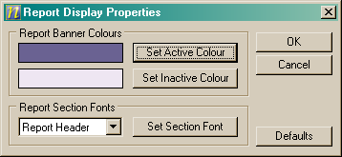
RptDisp.pas
The Report Display Properties dialog from the File menu on the Report Tree.

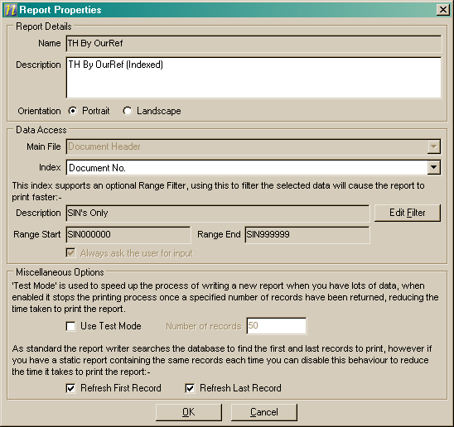

RptProp.pas
The Report Properties dialog available from the Report Designer window (MainForm.Pas).

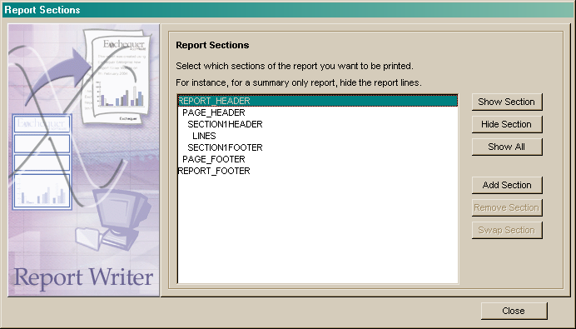

RptSections.pas
This form duplicates the Sections tab of the Add Report Wizard and is available from the Report Sections menu option in the Report Designer window.

NOTE: Maintainers need to be aware that any changes to the Sections Tab or this dialog need to be duplicated in RptWizard.Pas.

RptTree.pas
The Report Tree window:-

procedure FormCreate(Sender: TObject)
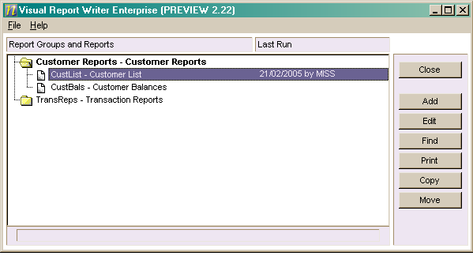
Calls GetReportTree in RepEngine.Dll to get a IRWReportTree_Interface object, checks the command line parameters, uses the COMTK to get the decimal places, deletes any *.TMP files in SWAP\ and displays the Beta warning window.

procedure FormActivate(Sender: TObject)
Closes the VRW if the params are invalid or the Beta terms were not accepted.

procedure FormShow(Sender: TObject)
Calls RefreshReportTree to load the report tree.

procedure FormDestroy(Sender: TObject)
Deletes any ERW*.TMP or *.EDF files in the SWAP\ directory. NOTE: Is this going to clash with the Paperless Module?

procedure RefreshReportTree
Loads the Report Tree using an IRWReportTree_Interface object.

NOTE: Due to the RptTree.Dat file structure we are limited to 99 folders as Andy is using a 2 char numeric string to id the groups and reports in the tree. Also the next number is being calculated when the tree loads instead of when an item is added, this will cause duplicate Id’s across multiple machines, reports added into folders with duplicate Id’s will appear in the first folder in the tree with that Id.
UPDATE: This was changed to 4 char/9999 before release and the bug across multiple instances was fixed in Apr05.
UPDATE (May 05): The Report Tree now uses the new IVRWReportData interface and TVRWReportData class, which removes the restriction on the number of folders.

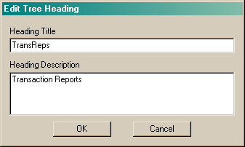
RptTreeEdt.pas
A second Report name/description dialog used by the Report Tree when the user edits a Report Group, this could probably be combined with RptCopy.Pas.

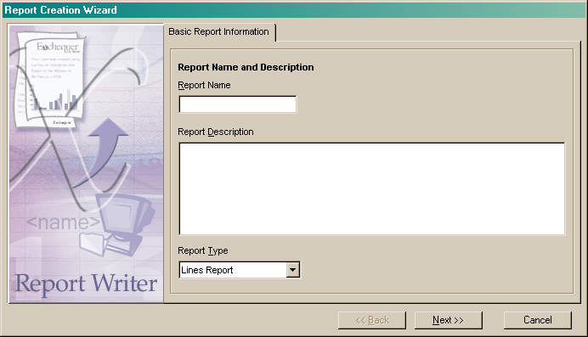
RptWizard.pas
This form contains the Add Report Wizard, each page is stored on a TabSheet within a PageControl. The Add Report Wizard is run from the NewReport method on the Report Designer window (MainForm.Pas) which itself is called from the Add button on the Report Tree.

NOTE: The Sections page of the wizard is duplicated in RptSections.Pas

RWDivider.pas
This unit contains the TRWDivider component.

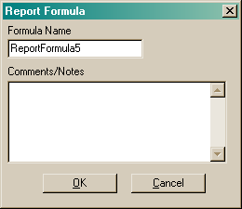

RWFormulaName.pas
This is the Formula name/notes dialog accessible from the popup menu on formula controls.

NOTE: This is very similar to RepTreeEdt.Pas, maybe a common form could be used.

SortPageEdt.pas
A form containing Sort Order and Page Break lists for a field, although compiled into EntRW.Exe it doesn’t appear to be referenced other than in EntRW.DPR.

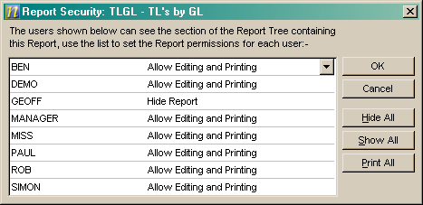
TreeSecurity.pas
This is the User based security dialog for the Report Tree, it uses an object returned by the IRWReportTree_Interface.GetSecurity method for accessing and saving the list of users and their permissions..

Code in X:\ENTRPRSE\VRW\Common

CIS.PAS
CIS Employee functions, it doesn’t appear to be referenced anywhere in the Visual Report Writer projects.

CtrlPrms.pas
This unit contains the record structures used to pass report and control information between EntRW.Exe and RepEngine.Dll.

DLLINT.PAS
A copy of FormDes2\DllInt.Pas – why is this duplicated?

EntLicence.pas - REMOVED
A copy of Funcs\EntLicence.Pas – why is this duplicated?

FORMUTIL.PAS
A copy of FormDes2\FormUtil.Pas without any identifiable changes – why is this duplicated?

GlobalTypes.pas
Misc constants, types, classes and variables.

Globtype.pas
Copy of FormDes2\GlobType.Pas and contains the Form Designer global structures – why is this needed and why is it duplicated?

History.Pas
The version numbers and change history.

MCUTIL.PAS
Not referenced anywhere in the code – appears to have been copied from FormDes2.

MCVARS.PAS
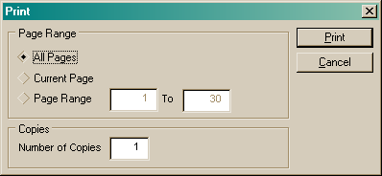
Not referenced anywhere in the code – appears to have been copied from FormDes2.

PAGEDLG.PAS
Used by the print preview dialog (ReportEngine\PrntPrev.Pas) to allow the user to print specific page ranges, etc… This appears to be a copy of FormDes2\PageDlg.Pas without any changes.

PRINTFRM.PAS
A copy of R&D\PrintFrm.Pas with the implementation of the functions replaced by ShowMessages! NOTE: There is another PrintFrm.Pas in the ReportEngine director which has empty implementors.
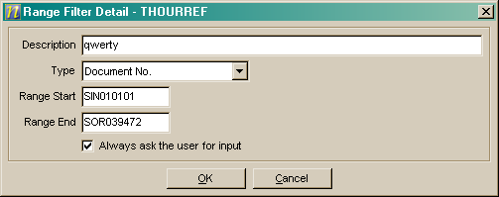

RangeFilterDetF.pas
The Range Filter Definition Detail window used by the Range Filters List (RangeFiltersF.PAS) and directly from the DB Field controls popup menu and from the Report Properties dialog on indexed reports where Range Filters are supported by the index.

RangeFiltersF.pas
The Range Filter List window accessed through the Report Designer Window and also used by the printing routines.

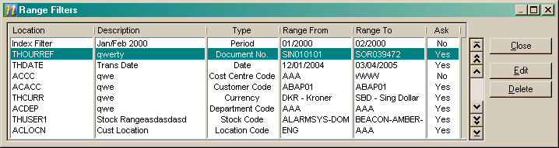

RECURSE.PAS
Not referenced anywhere in the code – appears to have been copied from FormDes2.

RECURSER.PAS
Only referenced from Recurse.Pas in the code – appears to have been copied from FormDes2.

RepEngIf.Pas
Contains the IReport_Interface and IRWReport_Interface interfaces that are used to interface the TReportEngine object returned by the GetReportEngine function in RepEngine.Dll to other Delphi applications. Used by EntRW, RepEngine, Sentimail and the Tools Menu.

RepTreeIF.pas
Deprecated
Contains the IReportTree_Interface and IRWReportTree_Interface interfaces that are used to interface the objects supported by RepEngine.Dll to other Delphi applications. Used by EntRW, RepEngine, Sentimail and the Tools Menu.

IVRWReportData should now be used instead of these interfaces.

RPCOMMON.PAS
Constants and key building routines for Reports.Dat and Dictnary.Dat - only referenced from Components\Common\RepTree.Pas in the code which is not needed – appears to have been copied from FormDes2.

RptEngDll.pas
Contains import declarations and type definitions for RepEngine.Dll.

RWOPENF.PAS
Declares and defines the structure for Reports.Dat and Dictnary.Dat, opens SysF and DictF, also initialises the DataFilesL, RepInpTypesL and FastNDXHedL global arrays which are defined in VarFPosU. NOTE: A number of other arrays which don’t appear to be used are also initialised.

SBSFUNCS.PAS
Contains an IIF function which works on Variants - although referenced from ReportEngine\PrntPrev.Pas it doesn’t appear to be used, alsothe standard Funcs\IIFFuncs.Pas unit should be used instead.

SBSLIST.PAS
Contains TSBSList (a TList descendant) which is used by DLLInt.Pas – duplicate version of FormDes2\SBSList.Pas.

SERIALNO.PAS
Not referenced anywhere in the code – appears to have been copied from FormDes2.

VRWReportDataIF.pas
Contains IVRWReportData and IVRWReportDataEditor interfaces, which define the interfaces for accessing and editing the report tree stored in VRWTree.Dat. The structure of the interfaces is based on the structure used for the COM Toolkit, so it includes GetFirst, GetNext, Add, Update, etc.

Code in X:\ENTRPRSE\GUIRW\Components\Common\

DDFuncs.pas
Data Dictionary access routines

PRNTDLG2.PAS
This appears to be an unchanged copy of RepWrt\PrntDlg2.Pas and is referenced by EntRW.Dpr and FrmThrdU.Pas, however there is a different PrntDlg2.Pas in the ReportEngine directory which appears to be the correct one of the Visual Report Writer. This duplicate needs removing to prevent confusion.

Code in X:\ENTRPRSE\GUIRW\Components\ReportContainer

AlignList.pas
Contains the TAlignmentObj which is used by the TRWRegion component for the align functions on the popup menu.

CtrlList.pas
Contains the TControlList class which is used by the TRWRegion component for storing the list of controls within each region.

ReportRegion.pas
Appears to be a wrapper for TRWRegion which publishes it as a component- not referenced anywhere in the code.

RWRegion.pas
Contains the TRWRegion component which represents a report section within the Report Designer.

Code in X:\ENTRPRSE\GUIRW\Components\ReportControls\

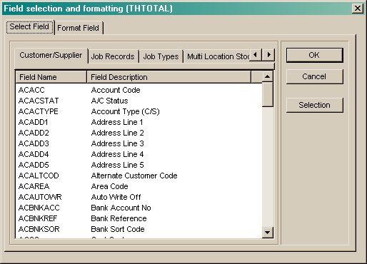
CtrlBase.pas
Contains the TReportCtrlBase component.

DBFieldSelect.Pas
DB Field Detail window displayed by the TReportDBField component.

GraphicCtrl.pas
Contains the TGraphicalCtrl class.

RWDBField.pas
Contains the TReportDBField component.
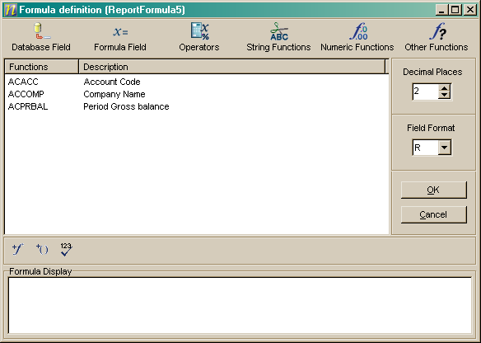

RWFormula.pas
Contains the TReportFormula component.

RWFormulaDef.pas
This is the Formula Detail window from the Report Designer displayed by the TReportFormula control.

RWImage.pas
Contains the TReportImage component.

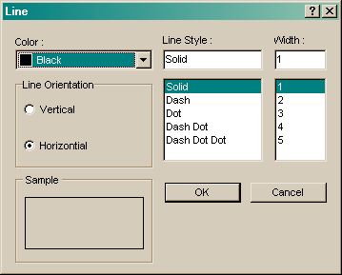
RWLine.pas
Contains the TReportLine component.

RWLineSelect.pas
This is the Report Designer’s Line Control property dialog as displayed by the TreportLine component.

RWText.pas
Contains the TReportText component.

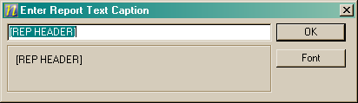
RWTextEntry.pas
This is the Report Designer’s Text Control property dialog displayed by the TreportText component.

TextCtrl.pas
Contains the TRWTextCtrl component.

Code in X:\ENTRPRSE\VRW\RepEngine

DbAccessFilter.pas
Contains the TAccessFilter class which is used by TReportGenerator (ReportGen.Pas) to generate the dataset for the report using Paul’s TReportWriterEngine class.

DBFutil.PAS
Misc global variables and utility functions for interfacing to DBFWrite.Dll for creating DBF Files.

FrmThrdU.pas
Threading routines? Although compiled into RepEngine.Dll it doesn’t appear to be referenced other than in RepEngine.Dpr, this module is also duplicated in GUIRW\Basic UI Test\.

oRepEngine.Pas (Formerly RepEngImp.Pas)
Contains the TReportEngine class which is returned by the GetReportEngine function which is exported from RepEngine.Dll.

oRepEngineManager.Pas
This class controls the opening and closing of the data files within RepEngine.Dll through interface references and reference counting. This complex mechanism was developed in Apr05 because of the total balls up Andy made of this area, and because of issues loading Enterprise (20 second delays) and issues changing companies within Enterprise.

oRepGenerator (Formerly ReportGen.pas)
Contains the TReportGenerator class which controls the printing process.

oRepTree.Pas (Formerly RepTreeIMP.pas)
Deprecated
Contains the TReportTree class which is returned by the GetReportEngine function which is exported from RepEngine.Dll. This is now only used by the report selection tree from the Tools | Options menu of Exchequer, and it uses an internal instance of the TVRWReportData class to actually access the data.

VRWReportData.pas should now be used instead of this unit.

oRepTreeSecurity.pas
Contains the GetReportSecurity and GetUserPermissions functions which are used to get and check User/Report Security.

PRINTFRM.PAS
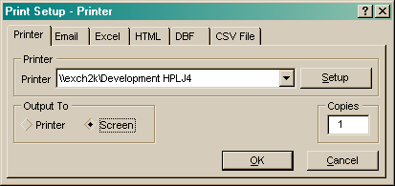
A copy of RepWrt\PrintFrm.Pas. NOTE: There is another PrintFrm.Pas in the GUIRW\Common director which has ShowMessages in the functions.

PrntDlg2.pas
This is the Print To dialog used by the Report Engine.

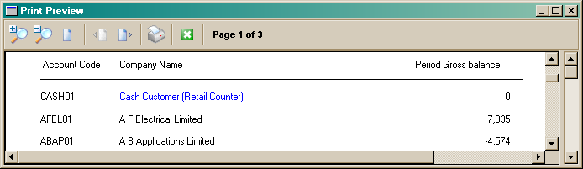

PrntPrev.pas
This is the Print Preview window used by the Report Engine, it as a copy of RepWrt\PrntPrev.Pas with mods to support the Drill-Down to Enterprise from the fields.

RepEngine.Dpr
Exports the GetReportEngine: IReport_Interface, GetReportTree: IReportTree_Interface and GetVRWReportEngine: IVRWReportData functions which are used by the Visual Report Writer, Sentimail and the Enterprise Tools Menu for accessing and printing VRW reports.

RptPersist.pas
Contains the TReportPersistor class which loads and saves the reports to the REPORTS\*.ERF files.

RptTreeF.pas
This unit contains the declaration and definition code for RWTree.Dat and RWUser.Dat and is a copy of GUIRW\Basic UI Test\RptTreeF.Pas or vicey-versa – need to move one of them to a common location and all apps use that.

RWOpenF.Pas
Contains global vars and routines needed to get everything to compile.

RWPRINTR.PAS
Contains the routines for outputting the report to printer/preview/email/fax/PDF/…

VarConst.Pas
A VarConst.Pas which is specific to RepEngine.Dll as it doesn’t open the data files at startup and declares the VRW data structures.

VARFPOSU.PAS
Contains loads of global variable arrays and constants for the Windows Report Writer - it is referenced from the VRW code but most of this module will be obsolete.

VRWReportDataU.pas
Contains the TVRWReportData class, an implementation of the IVRWReportData interface. This basically replaces the TRepTree class defined in oRepTree.pas.

Code in X:\ENTRPRSE\VRW\RWReader

oReportDetail.pas
Contains the TReportDetails class which implements the IReportDetails interface, an instance of this class is returned by the rwrGetReportDetails function.

oReportTree.pas
Contains the TReportTree class which implements the IReportTree interface, an instance of this class is returned by the rwrGetReportTree function.

RWReader.dpr
This is the Delphi 6.01 Project for RWReader.Dll which is used by the Visual RW to read and import the Windows RW Reports.

Function rwrInit (Const DataPath : ShortString) : LongInt

Function rwrDeInit : LongInt

Function rwrGetReportTree : IReportTree

Function rwrGetReportDetails (Const ReportCode : ShortString) : IReportDetails

RWRIntF.pas
This module contains the interface declarations, IReportTree and IReportDetails, for the public functions exported by RWReader.Dll

Classes

TAccessFilter – GUIRW\ReportEngine\DbAccessFilter.Pas
This class is the link between TReportGenerator and TReportWriterEngine and is responsible for building the dataset and loading it into memory to be reported upon:-

Constructor Create(ReportConstruct : TReportConstructInfo; ProgressEvent : TProgressMonitorEvent)
Creates the global RepExLocal : TdPostExLocalPtr object (ExBtTH1U.Pas) and within it opens up files 1-15 & DictNary.Dat using ClientId 14. The same files are then opened globally as well. A TReportWriterEngine object is then created and configured.

Procedure BuildSelection(DBSelectionList : TList)
Builds a list of all the DB Fields and formula’s in the order they are needed, if required it displays the Input Fields dialog (InputListDlg.Pas). It then adds the DB Fields and Input Fields into the TReportWriterEngine object

procedure BuildDataSet
Calls TReportWriterEngine.Execute to build the results set for the fields built up by BuildSelection, the drill-down info for the preview window is also generated by Execute as the VRW doesn’t know enough info to build the keys.

The resultset is then accessed using the GetFirst/GetNext methods and a TDBRowObject is created for each row containing the field values and drill-down information. The TDBRow objects are then stored in FrowList : TstringList with the string property of the list containing the field values concatenated together with ~ delimiters.

Note: This approach does cause a problem because of extreme (>700Mb) memory use on large reports and needs to be rewritten.

Property RawReportData : TstringList – maps onto FRowList created in BuildDataSet.

TAlignmentObj - GUIRW\Components\ReportContainer\AlignList.Pas
This is used by the TRWRegion component for storing the list of multi-selected controls, and performing operations on them such as aligning controls and dragging them around.

TControlList – GUIRW\Components\ReportContainer\CtrlList.Pas
This class is used by the TRWRegion component to store the controls within the region.

TReportEngine – GUIRW\ReportEngine\RepEngImp.Pas
This class implements the IReport_Interface and IRWReport_Interface interfaces and is used for loading, saving and printing a single report, whilst simple tools like Sentimail and the Tools Menu use IReport_Interface the Visual RW uses the additional functionality of IRWReport_Interface:-

function CreateReport(const ReportHnd : TMemoryStream) : LongInt
Called from the Designer window (MainForm.Pas) to initialise the object ready for a new report.

Function LoadReport(ReportHnd : TMemoryStream; UserID : ShortString; ReportCode : ShortString) : LongInt
Loads the specified report into the object using a TReportPersistor object and saves it to a temporary file in the SWAP directory, the filename is put into the memory stream for later reference.

NOTE: Instead of directly finding the record for ReportCode it appears to be sequentially processing the DB from the first record using the TReportTree object, for systems with a large number of reports this could be highly sub-optimal. Is this something to do with the user-based security?

Function PrintReport(var ReportHnd : TMemoryStream; ReportCode : ShortString) : LongInt
Called from the Report Tree and Report Designer to print the report, uses a TReportGenerator object to extract and print the data.

Function SaveReport(const ReportHnd: TMemoryStream; const ReportCode : ShortString) : LongInt
Calls RWSaveReport with same parameters – no additional code – no real value to function – may as well use RWSaveReport.

Function RWSaveReport(const ReportHnd: TMemoryStream; const ReportCode : ShortString) : LongInt
Uses the TReportPersistor object to save the report to its ERF file using WriteReportFile and update the temporary file in the SWAP directory using SaveObject.

TReportGenerator – GUIRW\ReportEngine\ReportGen.Pas
The TReportGenerator object (BP7 Dos Style) is used by TReportEngine.PrintReport to actually select and output the data, it descends from TthreadQueue to allow it to be used with the Enterprise threading:-

Constructor Create(AOwner : TObject; RptPersistor : TReportPersistor; ProgressEvent : TProgressMonitorEvent )
Creates a RAVE TReportFiler component and initialises its settings.

function Start : Boolean
Initialises the TReportGenerator settings and displays the ‘Print To’ dialog if required.

procedure Process
Calls the TReportFiler.Execute method to generate the report, this maps down onto the ProcessReport event handler.

procedure ProcessReport(Sender : TObject)
This is the event handler for the TReportFiler.OnPrint event and basically prints the report.

procedure DataRetrieve
Called by ProcessReport this function sets up the temporary file (ERW*.EDF), creates various lists to store data, builds a list of visible controls which is passed into TAccessFilter.BuildSelection calls TAccessFilter.BuildDataSet to generate the dataset and loads the results into Tlist/TstringLists in memory for processing.

Procedure PrintFormatReport
Called by ProcessReport when printing to everything other than CSV/DBF, this runs through the list of rows printing the headers/footers as req’d, updating totals and printing the data.

Procedure PrintRegion(const RegionIndex : SmallInt; const DataSetIdx : LongInt = -1)
Called by PrintFormatReport to print the specified region.

Procedure ReportToDBF(const DBFFilePath : ShortString; const OpenDBF : Boolean)
Called by ProcessReport when printing to DBF files. It calls CoInitialize, for Authoris-e, and creates an “EnterpriseDBF.DBFWriter” COM Object (DBFWrite.DLL) that provides an interface for creating DBF files. The file structure is defined, the file created and then the rows are written to the DBF File, CoUninitialize is then called and the .DBF file optionally opened.

Procedure ReportToCSV(const CSVFilePath : ShortString; const OpenCSV : Boolean)
Called by ProcessReport to print the dataset to a CSV file, after creating the file it optionally opens it.

Procedure Finish
Calls PrintFileTo (RWPrintR.Pas) which sends the report to the correct destination.

TreportPersistor – GUIRW\ReportEngine\RptPersist.Pas
This class performs the reading and writing of the reports from and to the ERF files in the reports directory.

constructor Create(ssFileName : ShortString; ssFilePath : ShortString; const bWizardBasedReport : Boolean = FALSE)
The report filename is specified when the persistor object is created, with the path being specified separately.

function GetRegionParamsByName(RegionName : ShortString; var RegionIdx : SmallInt; Caller : TCaller) : PregionParams
Returns a pointer to the TRegionParams record (CtrlPrms.Pas) for the specified region.

procedure LoadObject(const ReportHandle : TMemoryStream)
Reloads into the object the report saved into the temporary file in the SWAP directory by SaveObject.

procedure ReadReportFile
Loads the report into memory, the path and filename of the ERF file are specified as parameters on the constructor. See Code Walkthrough – Loading A Report for more info on this process.

procedure SaveObject(const ReportHandle : TMemoryStream; const bDispose : Boolean = FALSE)
Saves the currently loaded report into a temporary file (~RW*.TMP) in the SWAP directory.

procedure WriteReportFile
Saves the currently loaded report to the ERF file specified in the constructor parameters.

Getxxx Methods – various Getxxx methods are available for reading the details of the report from the persistor object.

NOTE: When the TReportPersistor loads the report most details are stored in pointers to records within private lists in the object, the pointers are then read and copied by other objects, TReportEngine, TReportGenerator, etc.. the TreportPersistor effectively “owns” the pointers to the records and is responsible for their de-allocation.

TReportTree – GUIRW\ReportEngine\RepTreeImp.Pas
This class implements the IReportTree_Interface and IRWReportTree_Interface interfaces and is used for maintaining the Report Tree, an instance of this object is returned from the GetReportTree function in RepEngine.Dll. Whilst simple tools like Sentimail and the Tools Menu use the IReportTree_Interface the Visual RW uses the additional functionality of IRWReportTree_Interface:-

Function AddTreeNode(Const TreeNodeType, TreeNodeName, TreeNodeDesc, TreeNodeParent, TreeNodeChild, FileName, LastRun : ShortString) : LongInt
Adds a new node into the report tree, or updates an existing node, will create RWTREE.DAT if missing.

NOTE: The check for an existing node is really inefficient – it does a GetFirst/GetNext checking the path – this could cause minor performance problems if you have hundreds of reports, it appears to be because there is no index on the reportname or filename within the data file.

Function CheckUserFile(const ssReportID : ShortString; var CanEdit : boolean) : boolean
Used by GetFirstReport/GetNextReport, returns TRUE if the current user has rights to see the report/group, the CanEdit parameter is used to determine if the user can edit the report.

function GetFirstReport(var TreeNodeType, TreeNodeName, TreeNodeDesc, TreeNodeParent, TreeNodeChild, FileName, LastRun : ShortString; var AllowEditReport : boolean) : LongInt
function GetNextReport(var TreeNodeType, TreeNodeName, TreeNodeDesc, TreeNodeParent, TreeNodeChild, FileName, LastRun : ShortString; var AllowEditReport : boolean) : LongInt
These functions are used to access the Report Tree database, both functions check the user security and will return blank details if the user isn’t allowed to access the report. NOTE: GetFirstReport will open the data files and GetNextReport closes them when it hits an error 9. GetFirstReport will also create the files if missing.

function GetGEqual(const Key : shortstring; var TreeNodeType, TreeNodeName, TreeNodeDesc, TreeNodeParent, TreeNodeChild, FileName, LastRun : ShortString; var AllowEditReport : boolean ) : LongInt
Tries to load a record Greater Than or Equal to the specified key, it assumes the data files are open and will return blank if no record was found, there was a btrieve error or the user doesn’t have rights to see the report it found. NOTE: I think this function was added for external apps.

function TReportTree.GetNext(var TreeNodeType, TreeNodeName, TreeNodeDesc, TreeNodeParent, TreeNodeChild, FileName, LastRun : ShortString; var AllowEditReport : boolean ) : LongInt
This appears to be identical to GetNextReport except that it doesn’t close the datafiles when it gets an error 9. NOTE: I think this function was added for external apps.

TVRWReportData
This class replaces the TReportTree class, and implements the IVRWReportData interface.

TReportWriterEngine – RepWrt\Engine\GUIEng.Pas
This is Paul’s class which extracts the data from the Enterprise database and returns it to the Visual Report Writer, it is based on the engine from the Windows Report Writer.

Components
The drag and drop run-time components for the report designer window all descend from Delphi’s TGraphicControl via TReportCtrlBase and either TGraphicalControl or TRWTextCtrl depending on whether their visible output is graphical or text based:-
TGraphicControl

TReportCtrlBase

TGraphicalCtrl
TRWTextCtrl

TReportDBField
TReportImage

TReportFormula
TReportLine

TReportText

TReportCtrlBase – GUIRW\Components\ReportControls\CtrlBase.Pas
This is a descendant of Delphi’s TgraphicControl and implements all the common control elements for selecting, moving, resizing, etc… controls.

TGraphicalCtrl – GUIRW\Components\ReportControls\GraphicCtrl.Pas
This is a descendant of TReportCtrlBase and is used as the common ancestor to all controls that do not output text, the painting is done by descendant classes overriding the virtual abstract PaintImage method.

TReportImage – GUIRW\Components\ReportControls\RWImage.Pas
This is a descendant of TGraphicalCtrl which is used for putting BMP, ICO and JPG files on the report.

TReportLine – GUIRW\Components\ReportControls\RWLine.Pas
This is a descendant of TGraphicalCtrl which is used for putting vertical or horizontal lines on the report.

TRWTextCtrl – GUIRW\Components\ReportControls\TextCtrl.Pas
This is a descendant of TReportCtrlBase and is used as the common ancestor to all controls that output text, the text to be printed is stored in the control’s Caption property and is automatically painted as necessary.

TReportDBField – GUIRW\Components\ReportControls\RWDBField.Pas
This is a descendant of TRWTextCtrl which implements the Database Field control.

TReportFormula – GUIRW\Components\ReportControls\RWFormula.Pas
This is a descendant of TRWTextCtrl which implements the Formula control.

TReportText – GUIRW\Components\ReportControls\RWText.Pas
This is a descendant of TRWTextCtrl which implements the Text control.

NOTE: The controls directly access the forms for the properties dialog.

Additionally the following components are used to create the designer area:-
TScrollBox

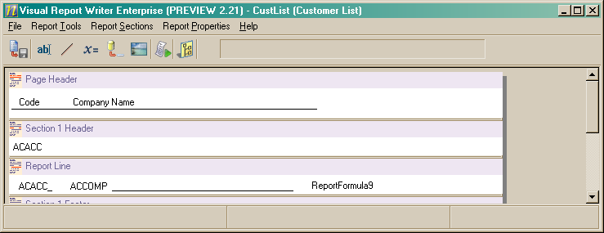
TRWRegion
TRWDivider
The drop shadow is just a dark grey panel positioned appropriately!

TRWDivider – GUIRW\Basic UI Test\RWDivider.Pas
This is a descendant of TPanel which is used for vertically resizing the regions, each divider controls the size of the region above it.

TRWRegion – GUIRW\Components\ReportContainer\RWRegion.Pas
This is a descendant of TPanel which is used as the design area for a specific section of the report, e.g. Page Header, Report Line, etc…

See also: TAlignmentObj, TControlList.

Third-Party Components

VirtualTree
The Report Tree display uses a Virtual Tree View component, from SoftGems (http://www.delphi-gems.com/VirtualTreeview/).

The simplest and most reliable way to install the required components is to use the installers in X:\COMPON\SoftGems. Both the Theme Manager and the Virtual Tree View need to be installed (in that order). Install them into the existing folders in X:\COMPON\SoftGems.

Interfaces – RepEngine.Dll

IReport_Interface – GUIRW\ReportEngine\ RepEngIF.Pas
This interface is returned by the GetReportEngine function exported by RepEngine.Dll, it is implemented by the TReportEngine class in RepEngImp.Pas. This interface is used by non-VRW applications to print VRW reports.

See also IRWReport_Interface.

IRWReport_Interface – GUIRW\ReportEngine\ RepEngIF.Pas
This interface is implemented by the same TReportEngine class that implements IReport_Interface, the Visual Report Writer actually typecasts the object returned by GetReportEngine to this interface as it provides additional functionality specifically for the VRW such as the creation of new reports and the saving of reports.

NOTE: Although this interface could have inherited from IReport_Interface it doesn’t as Andy didn’t know you could ☺

IReportTree_Interface – GUIRW\ReportEngine\ RepTreeIF.Pas
Deprecated
This interface is returned by the GetReportTree function exported by RepEngine.Dll, it is implemented by the TReportTree class in RepTreeImp.Pas. This interface is used by non-VRW applications to allow a Report Tree to be displayed for selecting a report, for example in the Sentimail Wizard and in the Tools Menu Administrator.

See also IRWReportTree_Interface.

IVRWReportData should be used instead of this interface.

IRWReportTree_Interface – GUIRW\ReportEngine\ RepTreeIF.Pas
Deprecated
This interface is implemented by the same TReportTree class that implements IReportTree_Interface, the Visual Report Writer actually typecasts the object returned by GetReportTree to this interface as it provides additional functionality specifically for the VRW for building and maintaining the Report Tree.

NOTE: Although this interface could have inherited from IReportTree_Interface it doesn’t as Andy didn’t know you could ☺

IVRWReportData should be used instead of this interface.

IVRWReportData – GUIRW\ReportEngine\VRWReportDataIF.pas
This interface replaces IReportTree_Interface and IRWReportTree_Interface, and is implemented by TVRWReportData. It provides access to the data file.

Interfaces – RWReader.Dll

IReportTree – GUIRW\RWReader\RWRIntf.Pas
Used by the rwrGetReportTree function in RWReader.Dll to return the Windows Report Writer Report Tree.

IReportDetails – GUIRW\RWReader\RWRIntf.Pas
Used by the rwrGetReportDetails function in RWReader.Dll to return the details of a specific report from the Windows Report Writer.

Code Walkthrough - Loading A Report
This section follows the process of loading a report into the Designer Window:-

In TfrmDesignWindow.FormShow:-
- Create Memory Stream (NOTE: This is used to store the path of the temporary file for LoadObject/SaveObject – it was originally used to store the report prior to LoadObject/SaveObject being written)
- Call ReportEngine.CreateReport passing in the memory stream
  - Create internal ReportPersistor object
- Call ReportEngine.LoadReport passing in the memory stream
  - Destroy any existing internal ReportPersistor object (like that we just created!)
  - Create internal ReportPersistor object
  - Call ReportPersistor.ReadReportFile
    - Call ReadHeader which loads the header details into the global ReportConstructInfo variable in GlobalTypes.Pas
    - While Not EOF
      - Read Region Id
      - Read RegionParams (structure = CtrlParms.TregionParams)
      - Insert RegionParams into RegionParmasList (Tlist)
      - Create ControlBlocks Tlist for current region
      - Call ReadCtrlBlocks which reads a series (0+) of CtrlPrms.TctrlParams into the ControlBlocks list
      - Add the ControlBlocks Tlist into the CtrlBlockList (Tlist) as an item
      - If any Bitmap controls were loaded
        - Create BitmapImages Tlist for region
        - Call ReadBitmaps to read the bitmaps out of the file into the BitmapImages Tlist
        - Add the BitmapImages Tlist into te BitmapList (TstringList) as an item
  - Call ReportPersistor.SaveObject to save the report we just loaded as a temporary file (~RWxxx.TMP) in the SWAP directory off of the dataset. Andy was unsure about the exact reason for this and thought it was something to do with historical memory corruption problems.
- Populate EntRW.Exe’s copy of the ReportConstructInfo variable in GlobTypes.Pas from the ReportEngine properties.
- Call TfrmDesignWindow.ShowReport which configures the designer window based on ReportConstructInfo and extracts all the control information from ReportEngine and creates the regions and controls.

Code Walkthrough - Printing a Report
This section follows through the process of printing a report from the report tree:-

In TfrmReportTree.OnButtonClick:-
- Call the GetReportEngine function exported from RepEngine.Dll to get a TreportEngine object and typecast it to a IRWReport_Interface
- Create a memory stream (NOTE: This is used to store the path of the temporary file for LoadObject/SaveObject)
- Set the ReportEngine datapath and link it to the ShowProgressMonitor event handler
- Call ReportEngine.LoadReport to load the report details, see Loading A Report for details on that process
- Call ReportEngine.PrintReport passing in the memory stream and the Report Code for the report we are printing
  - Call ReportPersistor.LoadObject to reload the report details from the temporary file created by LoadReport
  - Create a TReportGenerator object (BP7 dos style object – not a Delphi class)
    - Create TaccessFilter class which does the data access
    - Create and configure a RAVE TReportFiler component
    - Create RegionControls StringList
  - Call ReportGenerator.Start to configure the print setup info and, if required, display the Print To dialog.
  - Call ReportGenerator.Process to print the report
    - Call ReportGenerator.DataRetrieve
      - Generate temporary filename for rave file (ERWxxx.EDF)
      - Configure ReportFiler
      - Create internal lists for storing data and fields
      - Create a list of all the visible controls (RegionCtrlList) and the visible data controls (FDBSelection)
      - Call AccessFilter.BuildSelection passing in the list of visible data controls (FDBSelection)
      - Call AccessFilter.BuildDataSet to extract the selected rows to a temporary btrieve file in the SWAP directory and then copy them into a list in memory.
    - Call either ReportToDBF, ReportToCSV or PrintFormatReport depending on the destination to output the report in the correct format.
  - Call ReportGenerator.Finish to send it to the destination (printer/preview/email/…)
  - Destroy the TReportGenerator object
  - Call ReportPersistor.SaveObject
- Call IRWReportTree_Interface.EditTreeNode to update the report’s printed details
- Call RefreshReportTree to empty and reload the report tree – this may be out of order as it means that you lose your position and any open folders you may have.

User Based Security
There are currently three security permissions within Exchequer Enterprise pertaining to the Report Writers:-

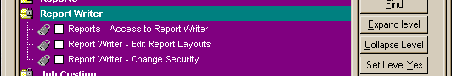

The VRW uses the first, “Access to Report Writer”, to determine whether the user is allowed to run the VRW, the second, “Edit Report Layouts”, is currently ignored and the third, “Change Security”, was added for the VRW to control whether the user is allowed to define the user-based security on the Report Tree

Within the VRW the current design of the Report Tree Security allows all users to see all reports and groups that haven’t had security defined for them. Security can be defined at a Group or Report level using the Report Security dialog on the File Menu:-

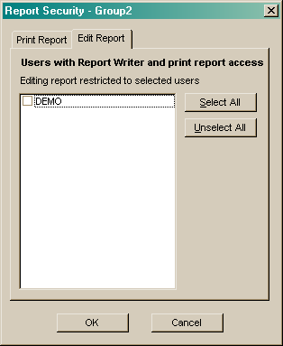
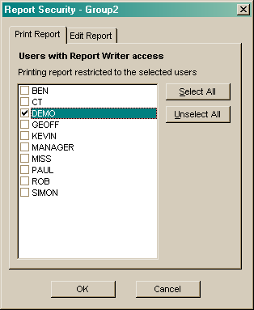

The ‘Print Report’ dialog lists those users allowed to run the Report Writer.

As soon as you tick any users that applies security to the Group/Report and only those users specified will be able to see the Group/Report.

Additionally those ticked users are added into the ‘Edit Report’ tab where you can specify which users are allowed to edit the report in the Designer.

However this same dialog is used for Groups as well, and how do you Print a Group?

Do reports in a group inherit the security of their parent group? And their parent’s parent? Etc…

Due to the extreme crapness of the current Report Tree and User Security data files this security is very hard to test, and if privileges are inherited from parent groups it becomes very difficult and inefficient.

Proposed Redesign “Kermit”

The security on groups should be limited to whether each individual user can see the group. The Group Security dialog should present a list of users who can see the group, i.e. taking into account any security on parent groups. If no Group Security has been defined then it will be assumed that the user can see the group.

Check for any Group/User Security records for the Group
If Found Then
Check for Group/User Security record for the User and Group
If Found Then
Result = Permission from Group/User Security Record
Else
Result = User Cannot See Group
Else
Result = User Can See Group

The security on reports will be three state – “Can’t see Report”, “Can Print Report”, “Can Print & Edit Report” – this provides additional functionality over what we currently have as it allows a report to be hidden for specific users. Again if no Report Security has been defined then it will be assumed that the user can print and edit the report:-

Check for any Report/User Security records for the Report
If Found Then
Check for Report/User Security record for the Report and User
If Found Then
Result = Permission from Group/User Security Record
Else
Result = User Cannot See Group
Else
Result = User Can Print and Edit the Report

